# Exercises: Introduction to Hibernate

This document defines the exercise assignments for the [“Spring Data” course @ SoftUni](https://softuni.bg/trainings/3852/spring-data-october-2022).

## Setup

Use the **provided skeleton** to create **soft_uni** database.

1. Change the **port**, **username** and **password** accordingly to your settings.

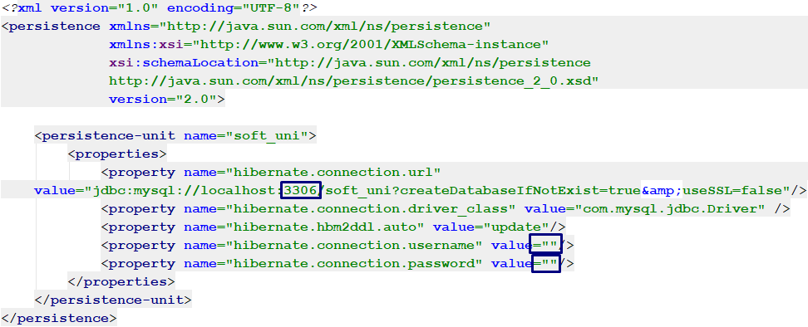

1. **Create** EntityManagerFactory and **run** your program.



1. Fill the database into **Workbench** or **IntelliJ** by **executing** the provided **.sql** script.

## Change casing

Use the **soft_uni** database. Persist **all towns** from the database. Detach those whose name length is **more than 5 symbols**. Then transform the **names** of all attached towns **to uppercase** and **save them to the database**.

## Contains Employee

Use the **soft_uni** database. Write a program that checks if a given employee name **is contained in the database.**

### Example

|  |  |
| --- | --- |
| **Input** | **Output** |
| Svetlin Nakov | Yes |
| John Doe | No |

## Employees with Salary Over 50 000

Write a program that gets the first name of all employees who have salary over **50 000**.

### Example:

|  |
| --- |
| **Output** |
| Terri  Jean  Ken  … |

## Employees from Department

Extract all employees from the **Research and Development** department. Order them by **salary** (in ascending order), then by **id** (in **ascending** order). Print only their **first name**, **last name**, **department name** and **salary**.

### Example:

|  |
| --- |
| **Output** |
| Diane Margheim from Research and Development - $40900.00  Gigi Matthew from Research and Development - $40900.00  Michael Raheem from Research and Development - $42500.00  Svetlin Nakov from Research and Development - $48000.00  Martin Kulov from Research and Development - $48000.00  George Denchev from Research and Development - $48000.00  Dylan Miller from Research and Development - $50500.00 |

## Adding a New Address and Updating Employee

Create a new address with **text** "**Vitoshka 15**". Set that address to an **employee** with a **last name**, given as an input.

## Addresses with Employee Count

Find all addresses, **ordered** by the **number of employees** who live there (**descending**).

Take only the **first 10 addresses** and print their **address text**, **town name** and **employee count**.

**Example**

|  |
| --- |
| **Output** |
| 163 Nishava Str, ent A, apt. 1, Sofia - 3 employees  7726 Driftwood Drive, Monroe - 2 employees  ... |

## Get Employee with Project

Get an **employee by his/her id**. Print only his/her **first name**, **last name**, **job title** and **projects** (only their names). The projects should be **ordered** **by** **name** (ascending). The output should be printed in the format given in the example.

### Example

|  |  |
| --- | --- |
| **Input** | **Output** |
| 147 | Linda Randall - Production Technician  HL Touring Handlebars  ML Road Rear Wheel  Patch kit  Touring-1000 |
| 83 | John Evans - Production Technician  Half-Finger Gloves  LL Mountain Handlebars  Racing Socks  Women's Tights |

## Find Latest 10 Projects

Write a program that prints the **last 10 started projects**. Print **their name, description, start and end date** and **sort** **them by name** lexicographically. For the output, check the format from the example.

### Example

|  |
| --- |
| **Output** |
| Project name: All-Purpose Bike Stand  Project Description: Research, design and development of …  Project Start Date:2005-09-01 00:00:00.0  Project End Date: null  Project name: Bike Wash  Project Description: Research, design and development of …  Project Start Date:2005-08-01 00:00:00.0  Project End Date: null  Project name: HL Touring Frame  Project Description: Research, design and development of …  Project Start Date:2005-05-16 16:34:00.0  Project End Date: null  … |

## Increase Salaries

Write a program that increases the salaries of all employees, who are in the **Engineering**, **Tool Design**, **Marketing** or **Information Services** departments by **12%**. Then **print the first name, the last name and the salary** for the employees, whose salary was increased.

### Example

|  |
| --- |
| **Output** |
| Roberto Tamburello ($48496.00)  Gail Erickson ($36624.00)  Jossef Goldberg ($36624.00)  Terri Duffy ($71120.00)  … |

## Find Employees by First Name

Write a program that finds **all employees**, whose **first name starts with a pattern** given as an input from the console. Print their **first and last names**, their **job** **title** and **salary** in the format given in the example below.

* **Hint: The expected results of next exercises are with update of salaries in ex 10.**

### Example

|  |  |
| --- | --- |
| **Input** | **Output** |
| SA | Sariya Harnpadoungsataya - Marketing Specialist - ($16128.00)  Sandra Reategui Alayo - Production Technician - ($9500.00)  Sairaj Uddin - Scheduling Assistant - ($16000.00)  Samantha Smith - Production Technician - ($14000.00)  Sameer Tejani - Production Technician - ($11000.00)  Sandeep Kaliyath - Production Technician - ($15000.00) |

## Employees Maximum Salaries

Write a program that finds the **max salary** for each **department**. Filter the departments, which max salaries **are not in the range** between 30000 and 70000.

### Example

|  |
| --- |
| **Output** |
| Engineering 71120.00  Sales 72100.00  Marketing 16128.00  Production 84100.00  … |

## Remove Towns

Write a program that **deletes a town**,which name is given as an input. The program should **delete all addresses** that are in the given town. Print on the console the **number of addresses** that were **deleted**. Check the example for the output format.

### Example

|  |  |
| --- | --- |
| **Input** | **Output** |
| Sofia | 1 address in Sofia deleted |
| Seattle | 44 addresses in Seattle deleted |